Vertical Measurement

To measure elevations or the Z offset, the use of a plumb bob is required. This can be something as simple as a spanner tied to a length of line and lowered from one deck to the next. The plumb bob will also allow for accurate measurements in the X and Y direction when transposing them from one deck to the other.
The plumb bob works, of course, by gravity so generally points to the centre of the earth. This being the case, if the vessel is not in good trim, i.e. has a list, the resting position of the plumb bob may not be at the true vertical point under the place from which it is being held. This is very critical when transposing X and Y measurements from one deck to another.
http://people.cas.sc.edu/ajames/747/Field_Methods/Leveling_Short.pdf
http://www.westlat.com/Portals/5/PDF/Manuals/PLP-71.pdf
http://fathoniu.googlepages.com/12_UELSurveyingMeasurement.pdf
clinometers

Clinometer
A clinometer is a very simple instrument for measuring vertical angles at relatively poor accuracy.
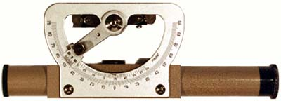

Examples Of Usage
Clinometers are be used for:
- Measuring the slope angle of a tape or chain during distance measurement.
- Estimating the height of a building or other feature using a vertical angle and a distance (determined by taping or pacing).

Factors Which Influence The Use Of Clinometers
- A clear line of sight between the user and the measured point is needed.
- A well defined object is required to obtain the maximum precison.
- The angle measurement precision and accuracy is limited to slightly better than one degree of arc.

Survey Methods Used For
Clinometers are used for the measurement of angles.

Surveying and navigation often rely on the measurement of two phenomena in order to determine position, those of distance and direction or bearing. The 'Angular Measurement' section will introduce the concept of bearings and cover the instrumentation that has been developed over the centuries to facilitate the determination of relative and absolute ‘bearing’. In order to start, we will look at the definition of some terms specific to the determination of direction.

Definitions
Directions
Simply that, a direction (over there)
Bearings
A direction relative to a datum
Whole-circle bearings
The direction of survey lines is generally expressed as an angle measured from a reference meridian, generally north, commencing from 0 degrees (0°) and increasing clockwise to 360 degrees (359°59'60"). Bearings are never expressed as "North, X degrees East".
Angles
The arithmetic difference between two directions or bearings.
Reference meridians
True north (through the geographic poles about which the Earth rotates)
Magnetic north - through which lines of magnetic flux pass
Grid north - mathematically determined value
An arbitrary meridian - one adopted for a particular project
Magnetic meridian - the direction of the earth's magnetic lines of force. This varies with date, time and locality.
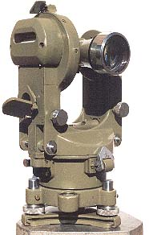

Field Use of the Theodolite
Theodolites are robust scientific instruments designed for use in the field. They are used primarily for the measurement of angular values in a traverse or network between survey marks, and are also used for defining directions of lines of sight.

Setting Up
Most theodolites are set up in a similar manner to a dumpy level except they are usually centred over a mark on the ground. Many surveyors have their secret method for performing this task rapidly, acquired over many years of practice.

To review how to set up a theodolite see Setting Up an Instrument 

http://www.sli.unimelb.edu.au/planesurvey/prot/equip/equip6-8.html

http://faculty.forestry.ubc.ca/bendickson/FOPRLibrary/Library/Surveying/Survey%20Tutorial.pdf
please print

